

Performance Reports

Wiltshire Council

Technical Specification

**Version 1.20**

**Document Version History**

|  |  |  |  |
| --- | --- | --- | --- |
| Version | Update Source | Date | Description |
| 1.0 | Garry Bleakley | 24-Jul-2014 | Initial Draft |
| 1.1 | Garry Bleakley | 28-Jul-2014 | Reformatted and pseudo code added |
| 1.2 | Garry Bleakley | 02-Sep-2014 | Updated with user amendments |

Table of Contents

1 About This Document 5

1.1 Document Purpose 5

1.2 Document Terminology 5

1.2.1 Abbreviations 5

1.2.2 Terms and Concepts 5

1.3 Related Documents 5

2 Requirements Overview 6

2.1 Business Problem 6

3 Technical Overview 6

3.1 Technologies and Programming Languages 6

4 Detailed Solution Design 6

4.1 Report Set 1 - Defect & PEM KPI’s by Area Board 6

4.1.1 Table “% Completed against target time by defect type” and Table “Average number of days to complete by defect type” 9

4.1.2 Table "% Highway defects completed against target time by priority" and "% PEM defects completed against target time" 12

% Highway defects completed against target time by priority 12

% PEM defects completed against target time 14

4.1.3 Table "Average number of days to complete highway defects by priority" and "Average number of days to complete PEM defects" 15

Average number of days to complete highway defects by priority 16

Average number of days to complete PEM defects 17

4.1.4 Table "% Find & fix/report defects completed against target time" and "Average number of days to complete find & fix/report defects" 19

% Find & fix/report defects completed against target time 19

Average number of days to complete find & fix/report defects 20

4.1.5 Table “Average Number of Days to Complete Potholes” 21

Average number of days to complete potholes 21

4.2 Report Set 2 – Pothole and PEM KPI’s by Area Board 22

4.2.1 Table "Pothole maintenance – Last four weeks", "Pothole maintenance – Preceding six months", "Pothole maintenance – Over seven months" – Reactive Pothole Maintenance 23

Pothole maintenance – Last four weeks 24

Pothole maintenance – Preceding six months 25

Pothole maintenance – Over seven months 27

Find & fix/report defects 28

4.2.2 Table "PEM defects – Last four weeks", "PEM defects – Preceding six months", "PEM defects – Over seven months" - Reactive Attendance (PEM) 29

PEM defects – Last four weeks 30

PEM defects – Preceding six months 31

PEM defects – Over seven months 32

4.3 Report Set 3 33

4.3.1 Table "Average number of days to instruct by defect type", "Average number of days to instruct highway defects", "Average number of days to instruct PEM defects" 36

Average number of days to instruct by defect type 36

Average number of days to instruct highway defects 38

Average number of days to instruct PEM defects 40

5 Appendices 42

5.1 Appendix A 42

5.1.1 IMF_MAI_INSPECTIONS 42

5.1.2 IMF_MAI_DEFECT_REPAIRS 42

5.1.3 IMF_MAI_WORK_ORDERS 44

5.1.4 IMF_NET_NETWORK_MEMBERS 45

5.2 Appendix B 46

5.2.1 MAI3806 – Defects 46

5.3 Appendix C 47

5.3.1 IMF Views ERD 47

# About This Document

## Document Purpose

This document specifies the implementation level technical design of the Performance Reports, for Wiltshire Council. This is based on the Performance Reports Specification provided by Wiltshire Council.

## Document Terminology

The following abbreviations, terms and concepts are used in the document:

### Abbreviations

|  |  |
| --- | --- |
| Abbreviation | Meaning, Definition |
| BSM | Bentley Solutions Methodology |
| IM | Information Manager |
| IMF | Information Manager Foundation Layer |
| KPI | Key Performance Indicatiors |
| POD | Information Manager Report |

### Terms and Concepts

|  |  |
| --- | --- |
| Term, Concept | Meaning, Definition |
| System | Physical (hardware) and logical (software) environment, required for the solution to operate, including the solution itself |

## Related Documents

Following is the list of documents that this document refers to or that provide with additional information about this topic.

|  |  |
| --- | --- |
| # | Document, Description |
| 1 | Wiltshire_Performance_Reports_Specification.docx |
| 2 | IMF4-Performance_Reports_Specification_Wiltshire.xlsx |

# Requirements Overview

## Business Problem

Wiltshire need to report their Defect KPI’s, by Area Board, for a specific set of date ranges.

# Technical Overview

To be able to provide Wiltshire their required Defect KPI’s, in an intuitive and interactive format. To enable Wiltshire to see “at a glance”, a pre-defined set of report statistics. This document contains conceptual screen shots/layouts of what the PODs might look like, including some pseudo code to describe the intention of each POD.

## Technologies and Programming Languages

Information Manager (IM) will be used to provide these summary statistics, utilizing the Information Manager Foundation Layer (IMF).

The views to be utilized for the reports construction, will be IMF_MAI_INSPECTIONS, IMF_MAI_DEFECT_REPAIRS, IMF_MAI_WORK_ORDERS & IMF_NET_NETWORK_MEMBERS. The view definitions are described in Appendix A.

# Detailed Solution Design

## Report Set 1 - Defect & PEM KPI’s by Area Board

* Summary statistics page needs to show stats per area board and stats for the county as a whole.
* There are 18 community area boards and they are set up under Road Type ***COMA***. They a referenced in the system as follows:

|  |  |
| --- | --- |
| Road Group | Road Group Description |
| COMM15 | Amesbury Community Area |
| COMM7 | Bradford On Avon Community Area |
| COMM5 | Calne Community Area |
| COMM3 | Chippenham Community Area |
| COMM4 | Corsham Community Area |
| COMM11 | Devizes Community Area |
| COMM1 | Malmesbury Community Area |
| COMM6 | Marlborough Community Area |
| COMM8 | Melksham Community Area |
| COMM12 | Pewsey Community Area |
| COMM18 | Salisbury Community Area |
| COMM19 | Southern Wilts Community Area |
| COMM16 | South West Wilt Community Area |
| COMM13 | Tidworth Community Area |
| COMM9 | Trowbridge Community Area |
| COMM2 | Royal WB & Crick Community Area |
| COMM14 | Warminster Community Area |
| COMM10 | Westbury Community Area |

* The whole county can be selected by using ‘Road Type’ TOP and ‘Road Group’ WILTSHIRE ROADS – ALL COUNTY ROADS IN WILTSHIRE
* The summary statistics page also needs the following programmed date ranges and should be pegged against the ‘Date Completed’ field in MAI3806.
* Last 7 days (include weekends)
* Last 4 weeks
* Last 3 months
* Last 6 months
* Last year
* Everything to date
* The summary page will be designed to look like the below, with links for each “date ranged” report. When you click the link in the field for the required Date Range & Area Board, it will drill down to the relevant table report, for the specific Area Board & Date Range selected.

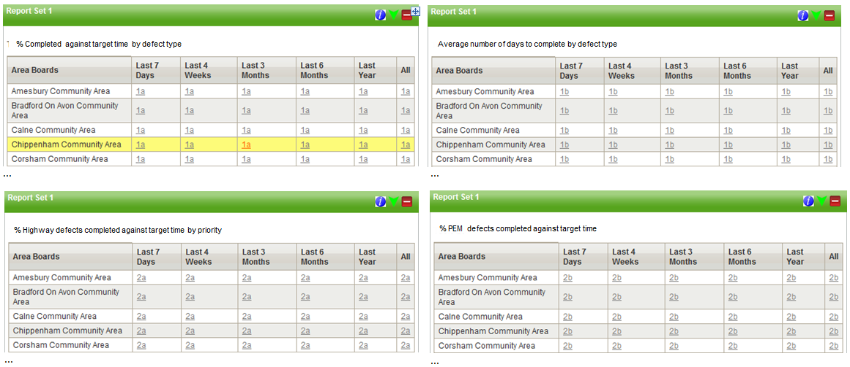

##### *Pseudo code*

Select a distinct list of Group Type ***COMA*** Descriptions from IMF_NET_NETWORK_MEMBERS, to get the 18 Area Boards, plus Group Type ***TOP*** and Group Description ***WILTSHIRE ROADS – ALL COUNTY ROADS IN WILTSHIRE***, for the whole county. This should give 19 rows in total.

The subsequent 6 columns for the date ranges will all drill down to the same respective POD (per table), but with a different calculated date range date.

Example: Report run on 1st July 2014.

Last 7 Days (sysdate-7) = javascript:doDrillDown('*IM_TABLE1A*',’ COMM15’, '24-JUN-2014’)

Last 4 Weeks (sysdate-28) = javascript:doDrillDown('*IM_TABLE1A*',’ COMM15’, '03-JUN-2014’)

Last 3 Months (add_months(sysdate,-3)) = javascript:doDrillDown('*IM_TABLE1A*',’ COMM15’, '01-APR-2014’)

Last 6 months (add_months(sysdate,-6)) = javascript:doDrillDown('*IM_TABLE1A*',’ COMM15’, '01-JAN-2014’)

Last year (add_months(sysdate,-12)) = javascript:doDrillDown('*IM_TABLE1A*',’ COMM15’, '01-JUL-2013’)

Everything to date javascript:doDrillDown('*IM_TABLE1A*',’ COMM15’, '01-JAN-1900’)

* Tables **"% Completed against target time by defect type", "Average number of days to complete by defect type", "% Highway defects completed against target time by priority", "% PEM defects completed against target time", "Average number of days to complete highway defects by priority", "Average number of days to complete PEM defects", "% Find & fix/report defects completed against target time" and "Average number of days to complete find & fix/report defects"** are shown below with instructions on which fields to read/filter the data from

### Table “% Completed against target time by defect type” and Table “Average number of days to complete by defect type”

Defects with the Initiation Type ‘CMT’ (*initiation_type*) to be excluded from tables “***% Completed against target time by defect type”***

& “***Average number of days to complete by defect type”*** as they will be reported separately

***% Completed against target time by defect type***

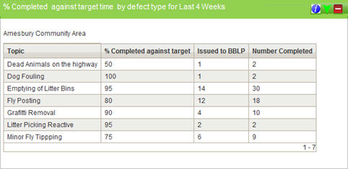

The table contains the following information

* **Activity codes** (*activity_code*) below identify each of the ‘Topic’ descriptions in Tables “% Completed against target time by defect type” and “Average number of days to complete by defect type”.

|  |  |
| --- | --- |
| DP | Dead Animals on the highway |
| AF | Dog Fouling |
| PL | Emptying of Litter Bins |
| FP | Fly Posting |
| GR | Grafitti Removal |
| SL | Litter Picking Reactive |
| FT | Minor Fly Tipping |

* **% completed against target time** – Measures ‘Date Completed’ (*defect_date_completed*) against ‘Date Repair Due’ (*date_due*). Date range filter (eg last 7 days, last 4 weeks) should be applied to the ‘Date Completed’ field in MAI3806 (see Appendix B for relevant fields from MAI3806).
* **Issued to BBLP –** Number of defects with the status ‘Instructed’ (*defect_status*). Date range filter should be applied to the Works Order ‘Date Instructed’ (*date_instructed*) field in MAI3806.
* **Number completed –** Number of defects with ‘Completed’ (*defect_status*) status. Date range filter applied to ‘Date Completed’ (*defect_date_completed*) in MAI3806.

##### *Pseudo code*

From the IMF_MAI_DEFECT_REPAIRS view, group by the 7 ACTIVITY_CODE’s.

* Join IMF_MAI_DEFECT_REPAIRS to IMF_MAI_INSPECTIONS
  + Then exclude any defects which have *initiation_type*=’CMT’
* Join IMF_MAI_DEFECT_REPAIRS to IMF_NET_NETWORK_MEMBERS
  + *network_element_id -> child_element_id*
  + Restrict to relevant parent element (e.g. ‘COMM15’), passed in from parent POD, to restrict to that Community Area’s defects
* ‘% Completed against target’ = calculate the percentage of the total number of defects & total number of defects where *defect_date_completed=date_due*. Defect counts are based on the date completed being greater than the date range value passed in from the parent POD, e.g. based on a report date of ’01-JUL-2014’ for the last 4 weeks:
  + *defect_date_completed* >= ’03-JUN-2014’
* ‘Issued to BBLP’ = count *defect_status*=’INSTRUCTED’. Need to join to IMF_MAI_WORK_ORDERS (WORKS_ORDER_NUMBER). Defect counts are based on date instructed being greater than the date range value passed in from the parent POD, e.g. based on a report date of ’01-JUL-2014’ for the last 4 weeks:
  + *date_instructed* >= ’03-JUN-2014’
* ‘Number Completed’ = count *defect_status*=’COMPLETED’. Defect counts are based on the date completed being greater than the date range value passed in from the parent POD, e.g. based on a report date of ’01-JUL-2014’ for the last 4 weeks:
  + *defect_date_completed* >= ’03-JUN-2014’

***Average number of days to complete by defect type***

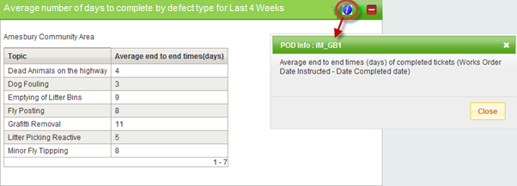

The table contains the following information

* **Activity codes** (*activity_code*) below identify each of the ‘Topic’ descriptions in Tables “% Completed against target time by defect type” and “Average number of days to complete by defect type”.

|  |  |
| --- | --- |
| DP | Dead Animals on the highway |
| AF | Dog Fouling |
| PL | Emptying of Litter Bins |
| FP | Fly Posting |
| GR | Grafitti Removal |
| SL | Litter Picking Reactive |
| FT | Minor Fly Tipping |

* **Average end to end times in days –** Measure from ‘Date Instructed’ (*date_instructed*) to ‘Date Completed’ (*defect_date_completed*) in the Defects form. Date range filter should be applied to the ‘Date Completed’ (*defect_date_completed*) field in MAI3806. The reason for measuring from date instructed is because we need to measure the performance of the contractor and the date instructed is the date they will receive the electronic works order. There will be a separate report for measuring the client part of the process.

##### *Pseudo code*

From the IMF_MAI_DEFECT_REPAIRS view, group by the 7 ACTIVITY_CODE’s.

* Join IMF_MAI_DEFECT_REPAIRS to IMF_MAI_INSPECTIONS
  + Then exclude any defects which have *initiation_type*=’CMT’
* Join IMF_MAI_DEFECT_REPAIRS to IMF_NET_NETWORK_MEMBERS
  + *network_element_id -> child_element_id*
  + Restrict to relevant parent element (e.g. ‘COMM15’), passed in from parent POD, to restrict to that Community Area’s defects
* Average end to end times in days – calculate the average of *defect_date_completed-date_instructed*. Defect counts are based on the date completed being greater than the date range value passed in from the parent POD, e.g. based on a report date of ’01-JUL-2014’ for the last 4 weeks:
  + *defect_date_completed* >= ’03-JUN-2014’

### Table "% Highway defects completed against target time by priority" and "% PEM defects completed against target time"

Please note: Defects with the initiation type CMT to be excluded from the statistics in Table "% Highway defects completed against target time by priority" & "% PEM defects completed against target time"

In tables ***"% Highway defects completed against target time by priority"*** & ***"% PEM defects completed against target time"***, defects are split by priority codes.

Street scene activities are also excluded from table ***"% Highway defects completed against target time by priority"***.

Underneath each table, the activity codes to be included are in **blue**. For the attendance defects A1 – A4 most activities are included.

#### % Highway defects completed against target time by priority

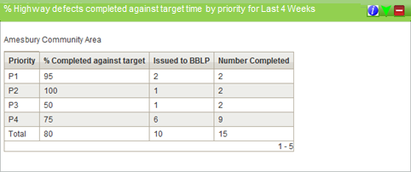

Table “**% Highway defects completed against target time by priority”** will be based on activity types: **CK, CL, CW, DC, DD, FW, HF, HO, KE, RA, SB, SF, SN, TH, VG, VK,WM**

The table contains the following information

* **Priority:** Defect Priorities (*priority*)

|  |  |
| --- | --- |
| P1 | 1,1P |
| P2 | 2 |
| P3 | 3 |
| P4 | 4 |

* **% completed against target time** – Measures ‘Date Completed’ (*defect_date_completed*) against ‘Date Repair Due’ (*date_due*). Date range filter (eg last 7 days, last 4 weeks) should be applied to the ‘Date Completed’ field in MAI3806 (see Appendix B for relevant fields from MAI3806).
* **Issued to BBLP –** Number of defects with the status ‘Instructed’ (*defect_status*). Date range filter should be applied to the Works Order ‘Date Instructed’ (*date_instructed*) field in MAI3806.
* **Number completed –** Number of defects with ‘Completed’ (*defect_status*) status. Date range filter applied to ‘Date Completed’ (*defect_date_completed*) in MAI3806.

##### *Pseudo code*

From the IMF_MAI_DEFECT_REPAIRS view, group by the 4 Defect PRIORITY codes (plus a total row).

* Join IMF_MAI_DEFECT_REPAIRS to IMF_MAI_INSPECTIONS
  + Then exclude any defects which have *initiation_type*=’CMT’
* Join IMF_MAI_DEFECT_REPAIRS to IMF_NET_NETWORK_MEMBERS
  + *network_element_id -> child_element_id*
  + Restrict to relevant parent element (e.g. ‘COMM15’), passed in from parent POD, to restrict to that Community Area’s defects
* ‘% Completed against target’ = calculate the percentage of the total number of defects & total number of defects where *defect_date_completed=date_due*. Defect counts are based on the date completed being greater than the date range value passed in from the parent POD, e.g. based on a report date of ’01-JUL-2014’ for the last 4 weeks:
  + *defect_date_completed* >= ’03-JUN-2014’
* ‘Issued to BBLP’ = count *defect_status*=’INSTRUCTED’. Need to join to IMF_MAI_WORK_ORDERS (WORKS_ORDER_NUMBER). Defect counts are based on date instructed being greater than the date range value passed in from the parent POD, e.g. based on a report date of ’01-JUL-2014’ for the last 4 weeks:
  + *date_instructed* >= ’03-JUN-2014’
* ‘Number Completed’ = count *defect_status*=’COMPLETED’. Defect counts are based on the date completed being greater than the date range value passed in from the parent POD, e.g. based on a report date of ’01-JUL-2014’ for the last 4 weeks:
  + *defect_date_completed* >= ’03-JUN-2014’

#### % PEM defects completed against target time

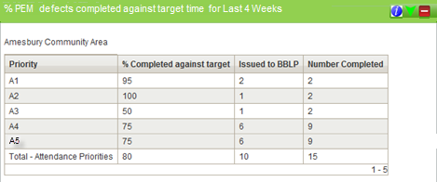

Table **"% PEM defects completed against target time"** will be based on activity types: AF, DP, FP, FT, GR, LC, NS, PA, PL, PT, SL, SW,WD CK, CL, CW, DC, DD, FW, HF, HO, KE, RA, SB, SF, SN, TH, VG, VK,WM

The table contains the following information

* **Priority:** Attendance Priorities (*priority*)

|  |
| --- |
| A1 |
| A2 |
| A3 |
| A4 |
| A5 |

* **% completed against target time** – Measures ‘Date Completed’ (*defect_date_completed*) against ‘Date Repair Due’ (*date_due*). Date range filter (eg last 7 days, last 4 weeks) should be applied to the ‘Date Completed’ field in MAI3806 (see Appendix B for relevant fields from MAI3806).
* **Issued to BBLP –** Number of defects with the status ‘Instructed’ (*defect_status*). Date range filter should be applied to the Works Order ‘Date Instructed’ (*date_instructed*) field in MAI3806.
* **Number completed –** Number of defects with ‘Completed’ (*defect_status*) status. Date range filter applied to ‘Date Completed’ (*defect_date_completed*) in MAI3806.

##### *Pseudo code*

From the IMF_MAI_DEFECT_REPAIRS view, group by the 4 Attendance PRIORITY codes (plus a total row).

* Join IMF_MAI_DEFECT_REPAIRS to IMF_MAI_INSPECTIONS
  + Then exclude any defects which have *initiation_type*=’CMT’
* Join IMF_MAI_DEFECT_REPAIRS to IMF_NET_NETWORK_MEMBERS
  + *network_element_id -> child_element_id*
  + Restrict to relevant parent element (e.g. ‘COMM15’), passed in from parent POD, to restrict to that Community Area’s defects
* JOIN IMF_MAI_DEFECT_REPAIRS to IMF_MAI_WORK_ORDERS
  + Work_order_number -> work_order_number
* ‘% Completed against target’ = calculate the percentage of the total number of defects & total number of defects where *defect_date_completed=date_due*. Defect counts are based on the date completed being greater than the date range value passed in from the parent POD, e.g. based on a report date of ’01-JUL-2014’ for the last 4 weeks:
  + *defect_date_completed* >= ’03-JUN-2014’
* ‘Issued to BBLP’ = count *defect_status*=’INSTRUCTED’. Need to join to IMF_MAI_WORK_ORDERS (WORKS_ORDER_NUMBER). Defect counts are based on date instructed being greater than the date range value passed in from the parent POD, e.g. based on a report date of ’01-JUL-2014’ for the last 4 weeks:
  + *date_instructed* >= ’03-JUN-2014’
* ‘Number Completed’ = count *defect_status*=’COMPLETED’. Defect counts are based on the date completed being greater than the date range value passed in from the parent POD, e.g. based on a report date of ’01-JUL-2014’ for the last 4 weeks:

*defect_date_completed* >= ’03-JUN-2014’

#### Average number of days to complete highway defects by priority

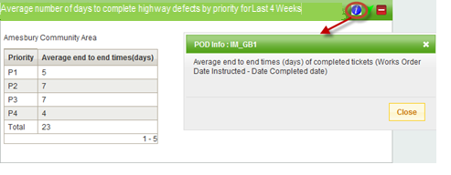

Table “Average number of days to complete highway defects by priority” will be based on the following activities CK, CL, CW, DC, DD, FW, HF, HO, KE, RA, SB, SF, SN, TH, VG, VK,WM

The table contains the following information

* **Priority**: Defect Priority (*priority*)

|  |  |
| --- | --- |
| P1 | 1,1P |
| P2 | 2 |
| P3 | 3 |
| P4 | 4 |

* **Average end to end times(days)** – Measure from ‘Date Instructed’ (date_instructed) to ‘Date Completed’ (defect_date_completed) in the Defects form. Date range filter should be applied to the ‘Date Completed’ (defect_date_completed) field in MAI3806. The reason for measuring from date instructed is because we need to measure the performance of the contractor and the date instructed is the date they will receive the electronic works order. There will be a separate report for measuring the client part of the process.

##### *Pseudo code*

From the IMF_MAI_DEFECT_REPAIRS view, group by the 4 Defect PRIORITY codes (plus a total row).

* Join IMF_MAI_DEFECT_REPAIRS to IMF_MAI_INSPECTIONS
  + Then exclude any defects which have *initiation_type*=’CMT’
* Join IMF_MAI_DEFECT_REPAIRS to IMF_NET_NETWORK_MEMBERS
  + *network_element_id -> child_element_id*
  + Restrict to relevant parent element (e.g. ‘COMM15’), passed in from parent POD, to restrict to that Community Area’s defects
* JOIN IMF_MAI_DEFECT_REPAIRS to IMF_MAI_WORK_ORDERS
  + Work_order_number -> work_order_number
* Average end to end times in days – calculate the average of *defect_date_completed-date_instructed*. Defect counts are based on date instructed being greater than the date range value passed in from the parent POD, e.g. based on a report date of ’01-JUL-2014’ for the last 4 weeks:
  + *date_instructed* >= ’03-JUN-2014’

#### Average number of days to complete PEM defects

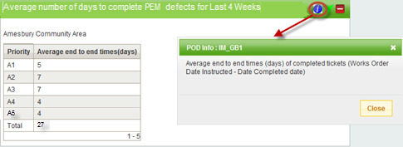

Table Average number of days to complete PEM defects will be based on the following activities AF, DP, FP, FT, GR, LC, NS, PA, PL, PT, SL, SW,WD CK, CL, CW, DC, DD, FW, HF, HO, KE, RA, SB, SF, SN, TH, VG, VK,WM

The table contains the following information

* **Priority**: Attendance Priorities (*priority*)

|  |
| --- |
| A1 |
| A2 |
| A3 |
| A4 |
| A5 |

* **Average end to end times(days)** – Measure from ‘Date Instructed’ (date_instructed) to ‘Date Completed’ (defect_date_completed) in the Defects form. Date range filter should be applied to the ‘Date Completed’ (defect_date_completed) field in MAI3806. The reason for measuring from date instructed is because we need to measure the performance of the contractor and the date instructed is the date they will receive the electronic works order. There will be a separate report for measuring the client part of the process.

##### *Pseudo code*

From the IMF_MAI_DEFECT_REPAIRS view, group by the 4 Attendance PRIORITY codes (plus a total row).

* Join IMF_MAI_DEFECT_REPAIRS to IMF_MAI_INSPECTIONS
  + Then exclude any defects which have *initiation_type*=’CMT’
* Join IMF_MAI_DEFECT_REPAIRS to IMF_NET_NETWORK_MEMBERS
  + *network_element_id -> child_element_id*
  + Restrict to relevant parent element (e.g. ‘COMM15’), passed in from parent POD, to restrict to that Community Area’s defects
* JOIN IMF_MAI_DEFECT_REPAIRS to IMF_MAI_WORK_ORDERS
  + Work_order_number -> work_order_number
* Average end to end times in days – calculate the average of *defect_date_completed-date_instructed*. Defect counts are based on the date completed being greater than the date range value passed in from the parent POD, e.g. based on a report date of ’01-JUL-2014’ for the last 4 weeks:
  + *defect_date_completed* >= ’03-JUN-2014’

### Table "% Find & fix/report defects completed against target time" and "Average number of days to complete find & fix/report defects"

Tables ***"% Find & fix/report defects completed against target time"*** & ***"Average number of days to complete find & fix/report defects"*** will report on defects logged in Exor via an interface with the contractors ‘find & fix’ app. These defects are identified by the Initiation Type CMT.

#### % Find & fix/report defects completed against target time

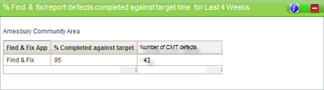

The table contains the following information

* **% completed against target time** – Measures ‘Date Completed’ (*defect_date_completed*) against ‘Date Repair Due’ (*date_due*). Date range filter (eg last 7 days, last 4 weeks) should be applied to the ‘Date Completed’ field in MAI3806 (see Appendix B for relevant fields from MAI3806).
* **Number of CMT defects** – counts the number of CMT defects in the area board

##### *Pseudo code*

From the IMF_MAI_DEFECT_REPAIRS view, calculate for all defects, with the following restrictions.

* Join IMF_MAI_DEFECT_REPAIRS to IMF_MAI_INSPECTIONS
  + Then **only** include defects which have *initiation_type*=’CMT’
* Join IMF_MAI_DEFECT_REPAIRS to IMF_NET_NETWORK_MEMBERS
  + *network_element_id -> child_element_id*
  + Restrict to relevant parent element (e.g. ‘COMM15’), passed in from parent POD, to restrict to that Community Area’s defects
* JOIN IMF_MAI_DEFECT_REPAIRS to IMF_MAI_WORK_ORDERS
  + Work_order_number -> work_order_number
* ‘% Completed against target’ = calculate the percentage of the total number of defects & total number of defects where *defect_date_completed=date_due*. Defect counts are based on the date completed being greater than the date range value passed in from the parent POD, e.g. based on a report date of ’01-JUL-2014’ for the last 4 weeks:
  + *defect_date_completed* >= ’03-JUN-2014’

#### Average number of days to complete find & fix/report defects

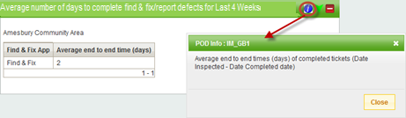

The table contains the following information

* **Average end to end time (days)** - Measures ‘Date Inspected’ (*date_inspected*) and ‘Date Completed’ (*defect_date_completed*). Date range filter (eg last 7 days, last 4 weeks) should be applied to the ‘Date Completed’ field in MAI3806 (see Appendix B for relevant fields from MAI3806).

##### *Pseudo code*

From the IMF_MAI_DEFECT_REPAIRS view, calculate for all defects, with the following restrictions.

* Join IMF_MAI_DEFECT_REPAIRS to IMF_MAI_INSPECTIONS
  + Then **only** include defects which have *initiation_type*=’CMT’
* Join IMF_MAI_DEFECT_REPAIRS to IMF_NET_NETWORK_MEMBERS
  + *network_element_id -> child_element_id*
  + Restrict to relevant parent element (e.g. ‘COMM15’), passed in from parent POD, to restrict to that Community Area’s defects
* JOIN IMF_MAI_DEFECT_REPAIRS to IMF_MAI_WORK_ORDERS
  + Work_order_number -> work_order_number
* Average end to end times (days) – calculate the average of *defect_date_completed-date_inspected*. Defect counts are based on the date completed being greater than the date range value passed in from the parent POD, e.g. based on a report date of ’01-JUL-2014’ for the last 4 weeks:
  + *defect_date_completed* >= ’03-JUN-2014’

### Table “Average Number of Days to Complete Potholes”

#### Average number of days to complete potholes

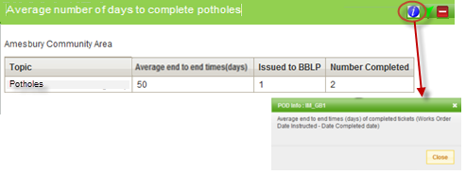

The table contains the following information

* Only return defects, where the defect code (*defect_type*) is **POTH**
* Defects with the initiation type CMT to be included in the statistics
* Exclude Attendance Priorities (A1, A2, A3, A4,A5)
* **Average end to end times(days)** – Measure from ‘Date Instructed’ (date_instructed) to ‘Date Completed’ (defect_date_completed) in the Defects form. Date range filter should be applied to the ‘Date Completed’ (defect_date_completed) field in MAI3806.
* **Issued to BBLP –** Number of defects with the status ‘Instructed’ (*defect_status*). Date range filter should be applied to the Works Order ‘Date Instructed’ (*date_instructed*) field in MAI3806.
* **Number completed –** Number of defects with ‘Completed’ (*defect_status*) status. Date range filter applied to ‘Date Completed’ (*defect_date_completed*) in MAI3806.

##### *Pseudo code*

From the IMF_MAI_DEFECT_REPAIRS view, group by the Defect code **POTH**.

Join IMF_MAI_DEFECT_REPAIRS to IMF_MAI_INSPECTIONS

* Join IMF_MAI_DEFECT_REPAIRS to IMF_NET_NETWORK_MEMBERS
  + *network_element_id -> child_element_id*
  + Restrict to relevant parent element (e.g. ‘COMM15’), passed in from parent POD, to restrict to that Community Area’s defects
* JOIN IMF_MAI_DEFECT_REPAIRS to IMF_MAI_WORK_ORDERS
  + Work_order_number -> work_order_number
* Average end to end times in days – calculate the average of *defect_date_completed-date_instructed*. Defect counts are based on the date completed being greater than the date range value passed in from the parent POD, e.g. based on a report date of ’01-JUL-2014’ for the last 4 weeks:

*defect_date_completed* >= ’03-JUN-2014’

* ‘Issued to BBLP’ = count *defect_status*=’INSTRUCTED’. Need to join to IMF_MAI_WORK_ORDERS (WORKS_ORDER_NUMBER). Defect counts are based on date instructed being greater than the date range value passed in from the parent POD, e.g. based on a report date of ’01-JUL-2014’ for the last 4 weeks:

*date_instructed* >= ’03-JUN-2014’

* ‘Number Completed’ = count *defect_status*=’COMPLETED’. Defect counts are based on the date completed being greater than the date range value passed in from the parent POD, e.g. based on a report date of ’01-JUL-2014’ for the last 4 weeks:

*defect_date_completed* >= ’03-JUN-2014’

## Report Set 2 – Pothole and PEM KPI’s by Area Board

* This report set needs to show stats per area board and stats for the county as a whole.
* There are 18 community area boards and they are set up under Road Type COMA. They a referenced in the system as per Report Set 1 above.
* The whole county can be selected by using ‘Road Type’ TOP and ‘Road Group’ WILTSHIRE ROADS – ALL COUNTY ROADS IN WILTSHIRE
* The summary page will be designed to look like the below, with links for each “date ranged” report. When you click the link in the field for the required Date Range & Area Board, it will drill down to the relevant table report, for the specific Area Board & Date Range selected.

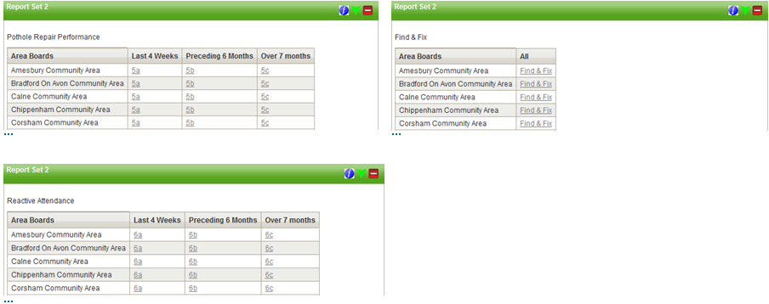

##### *Pseudo code*

Select a distinct list of Group Type ***COMA*** Descriptions from IMF_NET_NETWORK_MEMBERS, to get the 18 Area Boards, plus Group Type ***TOP*** and Group Description ***WILTSHIRE ROADS – ALL COUNTY ROADS IN WILTSHIRE***, for the whole county. This should give 19 rows in total.

The subsequent 3 columns for the date ranges will all drill down to the same respective POD (per table), but with a different calculated date range date. Examples below are showing passing in 2 dates for the Start & End date ranges.

Example: Report run on 1st July 2014.

Last 4 Weeks (sysdate-28) = javascript:doDrillDown('*IM_TABLE5A*',’ COMM15’, '03-JUN-2014’,’01-JUL-2014’)

Last 6 months (add_months(sysdate,-7)) = javascript:doDrillDown('*IM_TABLE5A*',’ COMM15’, '01-DEC-2013’,’02-JUN-2014)

Over 7 months (add_months(sysdate,-7)) = javascript:doDrillDown('*IM_TABLE5A*',’ COMM15’, '01-JAN-1900’,’01-DEC-2013)

* Tables **"Pothole maintenance – Last four weeks", "Pothole maintenance – Preceding six months" and "Pothole maintenance – Over seven months"** are shown below with instructions on which fields to read/filter the data from

### Table "Pothole maintenance – Last four weeks", "Pothole maintenance – Preceding six months", "Pothole maintenance – Over seven months" – Reactive Pothole Maintenance

* Tables ***"Pothole maintenance – Last four weeks", "Pothole maintenance – Preceding six months"*** and ***"Pothole maintenance – Over seven months"*** are a measure of pothole repair performance. There are three specific date ranges for these reports and they should be pegged against the Works Order ‘Date Instructed’ field in MAI3806.
  + **Last four weeks –** Pothole defects instructed in the last 4 weeks
  + **Preceding 6 months –** Pothole defects instructed in the 6 months preceeding (but not including) the last four weeks.
  + **Over seven months –** Pothole defects instructed over seven months ago (not including the last 4 weeks and preceeding 6 months).

Example: Report run on 1st July 2014.

Table 5a – last 4 weeks shows all pothole defects instructed from 03/06/2014 – 01/07/2014

Table 5b – Preceding 6 months shows defects instructed from 01/12/2013 -02/06/2016

Table 5c – Over seven months shows defects instructed before 01/12/2013

#### Pothole maintenance – Last four weeks

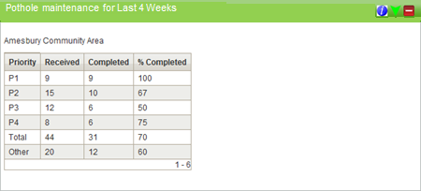

The table contains the following information

* Only return defects, where the defect code (*defect_type*) is **POTH**
* Defects with the initiation type CMT to be excluded from the statistics
* The figures in the **Total** column should exclude the figures from ‘**Other**’
* Measure of Pothole Repair Performance, for the **Last Four Weeks**.
* Priority Codes (*priority*) in Exor

|  |  |
| --- | --- |
| P1 | 1,1P |
| P2 | 2 |
| P3 | 3 |
| P4 | 4 |
| Other | 5,6,7 |

* **Received** - Number of pothole defects with the Status field in MAI3806 set to ‘INSTRUCTED’
* **Completed** – Number of pothole defects with the Status field in MAI3806 set to ‘COMPLETED’
* **% Completed -** % of those received that have been completed.

##### *Pseudo code*

From the IMF_MAI_DEFECT_REPAIRS view, group by the Defect PRIORITY codes (plus a total row).

* Join IMF_MAI_DEFECT_REPAIRS to IMF_MAI_INSPECTIONS
  + Then exclude any defects which have *initiation_type*=’CMT’
* Join IMF_MAI_DEFECT_REPAIRS to IMF_NET_NETWORK_MEMBERS
  + *network_element_id -> child_element_id*
  + Restrict to relevant parent element (e.g. ‘COMM15’), passed in from parent POD, to restrict to that Community Area’s defects
* JOIN IMF_MAI_DEFECT_REPAIRS to IMF_MAI_WORK_ORDERS
  + Work_order_number -> work_order_number
* **Received** – Count the number of pothole defects with the *defect_status* field set to ‘INSTRUCTED’
* **Completed** – Count the number of pothole defects with the *defect_status* field set to ‘COMPLETED’
* **% Completed -** calculate the percentage of the total number of Completed defects, from the total number of Recevied defects
* Defect counts are based on date instructed being greater than the date range value passed in from the parent POD, e.g. based on a report date of ’01-JUL-2014’ for the last 4 weeks:
  + *date_instructed* between ’03-JUN-2014’ and ’01-JUL-2014’

#### Pothole maintenance – Preceding six months

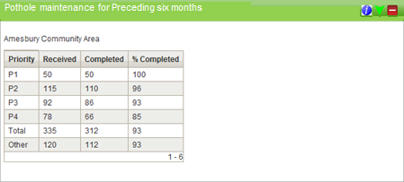

The table contains the following information

* Only return defects, where the defect code (*defect_type*) is **POTH**
* Defects with the initiation type CMT to be excluded from the statistics
* The figures in the **Total** column should exclude the figures from ‘**Other**’
* Measure of Pothole Repair Performance, for the **Preceding 6 Months** (but not including) the last four weeks..
* Priority Codes (*priority*) in Exor

|  |  |
| --- | --- |
| P1 | 1,1P |
| P2 | 2 |
| P3 | 3 |
| P4 | 4 |
| Other | 5,6,7 |

* **Received** - Number of pothole defects with the Status field in MAI3806 set to ‘INSTRUCTED’
* **Completed** – Number of pothole defects with the Status field in MAI3806 set to ‘COMPLETED’
* **% Completed -** % of those received that have been completed.

##### *Pseudo code*

* From the IMF_MAI_DEFECT_REPAIRS view, group by the Defect PRIORITY codes (plus a total row).

Join IMF_MAI_DEFECT_REPAIRS to IMF_MAI_INSPECTIONS

* + Then exclude any defects which have *initiation_type*=’CMT’
* Join IMF_MAI_DEFECT_REPAIRS to IMF_NET_NETWORK_MEMBERS
  + *network_element_id -> child_element_id*
  + Restrict to relevant parent element (e.g. ‘COMM15’), passed in from parent POD, to restrict to that Community Area’s defects
* JOIN IMF_MAI_DEFECT_REPAIRS to IMF_MAI_WORK_ORDERS
  + Work_order_number -> work_order_number
* **Received** – Count the number of pothole defects with the *defect_status* field set to ‘INSTRUCTED’
* **Completed** – Count the number of pothole defects with the *defect_status* field set to ‘COMPLETED’
* **% Completed -** calculate the percentage of the total number of Completed defects, from the total number of Recevied defects
* Defect counts are based on date instructed being greater than the date range value passed in from the parent POD, e.g. based on a report date of ’01-JUL-2014’ for the last 6 months (but not including) the last four weeks:
  + *date_instructed* between 01-DEC-2013’ and ’02-Jun-2014’

#### Pothole maintenance – Over seven months

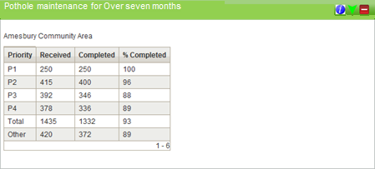

The table contains the following information

* Only return defects, where the defect code (*defect_type*) is **POTH**
* Defects with the initiation type CMT to be excluded from the statistics
* The figures in the **Total** column should exclude the figures from ‘**Other**’
* Measure of Pothole Repair Performance, for **Over 7 Months** (not including the last 4 weeks and preceeding 6 months).
* Priority Codes (*priority*) in Exor

|  |  |
| --- | --- |
| P1 | 1,1P |
| P2 | 2 |
| P3 | 3 |
| P4 | 4 |
| Other | 5,6,7 |

* **Received** - Number of pothole defects with the Status field in MAI3806 set to ‘INSTRUCTED’
* **Completed** – Number of pothole defects with the Status field in MAI3806 set to ‘COMPLETED’
* **% Completed -** % of those received that have been completed.

##### *Pseudo code*

From the IMF_MAI_DEFECT_REPAIRS view, group by the Defect PRIORITY codes (plus a total row).

* Join IMF_MAI_DEFECT_REPAIRS to IMF_MAI_INSPECTIONS
  + Then exclude any defects which have *initiation_type*=’CMT’
* Join IMF_MAI_DEFECT_REPAIRS to IMF_NET_NETWORK_MEMBERS
  + *network_element_id -> child_element_id*
  + Restrict to relevant parent element (e.g. ‘COMM15’), passed in from parent POD, to restrict to that Community Area’s defects
* JOIN IMF_MAI_DEFECT_REPAIRS to IMF_MAI_WORK_ORDERS
  + Work_order_number -> work_order_number
* **Received** – Count the number of pothole defects with the *defect_status* field set to ‘INSTRUCTED’
* **Completed** – Count the number of pothole defects with the *defect_status* field set to ‘COMPLETED’
* **% Completed -** calculate the percentage of the total number of Completed defects, from the total number of Recevied defects
* Defect counts are based on date instructed being greater than the date range value passed in from the parent POD, e.g. based on a report date of ’01-JUL-2014’ for over 7 months ago (not including the last 4 weeks and preceeding 6 months):
  + *date_instructed* between ’01-JAN-1900’ and ’31-NOV-2013’

#### Find & fix/report defects

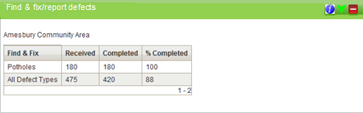

The table contains the following information

* Only return defects, where the defect code (*defect_type*) is **POTH**
* Include only Defects with the initiation type CMT
* All defect types is total of all CMT defects including potholes
* **Received** - Number of defects with Initiation Type CMT
* **Completed** – Number of defects with Initiation type CMT and the Status field in MAI3806 set to ‘COMPLETED’
* **% Completed** - % Of CMT defects received that have been completed.

##### *Pseudo code*

From the IMF_MAI_DEFECT_REPAIRS view, group by the Defect code **POTH** (plus a total row).

Join IMF_MAI_DEFECT_REPAIRS to IMF_MAI_INSPECTIONS

* + Then **only** include any defects which have *initiation_type*=’CMT’
* Join IMF_MAI_DEFECT_REPAIRS to IMF_NET_NETWORK_MEMBERS
  + *network_element_id -> child_element_id*
  + Restrict to relevant parent element (e.g. ‘COMM15’), passed in from parent POD, to restrict to that Community Area’s defects
* JOIN IMF_MAI_DEFECT_REPAIRS to IMF_MAI_WORK_ORDERS
  + Work_order_number -> work_order_number
* **Received** – Count the number of pothole defects with the Initiation Type CMT **Completed** – Count the number of pothole defects with Initiation type CMT and the *defect_status* field set to ‘COMPLETED’
* **% Completed -** calculate the percentage of the total number of Completed defects, from the total number of Recevied defects

### Table "PEM defects – Last four weeks", "PEM defects – Preceding six months", "PEM defects – Over seven months" - Reactive Attendance (PEM)

* Tables ***"PEM defects – Last four weeks", "PEM defects – Preceding six months"*** & ***"PEM defects – Over seven months"*** measure Reactive Attendance (PEM) defects. There are three specific date ranges for these reports and they should be pegged against the Works Order ‘Date Instructed’ field in MAI3806.

Reactive Attendance

#### PEM defects – Last four weeks

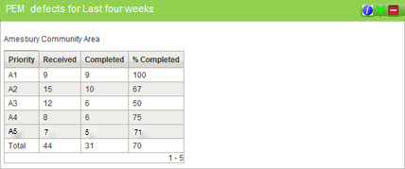

The table contains the following information

* Table ***"PEM defects – Last four weeks"*** will be based on the following activities - AF, DP, FP, FT, GR, LC, NS, PA, PL, PT, SL, SW,WD CK, CL, CW, DC, DD, FW, HF, HO, KE, RA, SB, SF, SN, TH, VG, VK,WM
* Measure of Attendance (PEM) Defects, for the **Last Four Weeks**.
* **Priority**: Attendance Priorities (*priority*)

|  |
| --- |
| A1 |
| A2 |
| A3 |
| A4 |
| A5 |

* **Received** - Number of defects with the Status field in MAI3806 set to ‘INSTRUCTED’
* **Completed** – Number of defects with the Status field in MAI3806 set to ‘COMPLETED’
* **% Completed** - % of those received that have been completed.

##### *Pseudo code*

From the IMF_MAI_DEFECT_REPAIRS view, group by the Attendance PRIORITY codes (plus a total row).

* + - Join IMF_MAI_DEFECT_REPAIRS to IMF_MAI_INSPECTIONS
* Then exclude any defects which have *initiation_type*=’CMT’
  + - Join IMF_MAI_DEFECT_REPAIRS to IMF_NET_NETWORK_MEMBERS
  + *network_element_id -> child_element_id*
  + Restrict to relevant parent element (e.g. ‘COMM15’), passed in from parent POD, to restrict to that Community Area’s defects
* JOIN IMF_MAI_DEFECT_REPAIRS to IMF_MAI_WORK_ORDERS
  + Work_order_number -> work_order_number
* **Received** – Count the number of defects with the *defect_status* field set to ‘INSTRUCTED’
* **Completed** – Count the number of defects with the *defect_status* field set to ‘COMPLETED’
* **% Completed -** calculate the percentage of the total number of Completed defects, from the total number of Recevied defects
* Defect counts are based on date instructed being greater than the date range value passed in from the parent POD, e.g. based on a report date of ’01-JUL-2014’ for the last 4 weeks:
  + *date_instructed* between ’03-JUN-2014’ and ’01-JUL-2014’

#### PEM defects – Preceding six months

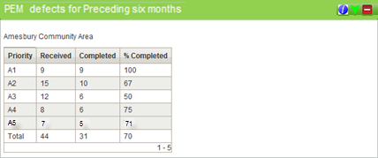

The table contains the following information

* Table **"PEM defects – Preceding six months"** will be based on the following activities - AF, DP, FP, FT, GR, LC, NS, PA, PL, PT, SL, SW,WD CK, CL, CW, DC, DD, FW, HF, HO, KE, RA, SB, SF, SN, TH, VG, VK,WM
* Measure of Attendance (PEM) Defects, for the **Preceding Six Months**.
* **Priority**: Attendance Priorities (*priority*)

|  |
| --- |
| A1 |
| A2 |
| A3 |
| A4 |
| A5 |

* **Received** - Number of defects with the Status field in MAI3806 set to ‘INSTRUCTED’
* **Completed** – Number of defects with the Status field in MAI3806 set to ‘COMPLETED’
* **% Completed** - % of those received that have been completed.

##### *Pseudo code*

From the IMF_MAI_DEFECT_REPAIRS view, group by the Attendance PRIORITY codes (plus a total row).

* + - Join IMF_MAI_DEFECT_REPAIRS to IMF_MAI_INSPECTIONS
* Then exclude any defects which have *initiation_type*=’CMT’
  + - Join IMF_MAI_DEFECT_REPAIRS to IMF_NET_NETWORK_MEMBERS
  + *network_element_id -> child_element_id*
* JOIN IMF_MAI_DEFECT_REPAIRS to IMF_MAI_WORK_ORDERS
  + Work_order_number -> work_order_number
* Restrict to relevant parent element (e.g. ‘COMM15’), passed in from parent POD, to restrict to that Community Area’s defects
* **Received** – Count the number of defects with the *defect_status* field set to ‘INSTRUCTED’
* **Completed** – Count the number of defects with the *defect_status* field set to ‘COMPLETED’
* **% Completed -** calculate the percentage of the total number of Completed defects, from the total number of Recevied defects
* Defect counts are based on date instructed being greater than the date range value passed in from the parent POD, e.g. based on a report date of ’01-JUL-2014’ for the last 6 months (but not including) the last four weeks:
  + *date_instructed* between 01-DEC-2013’ and ’02-Jun-2014’

#### PEM defects – Over seven months

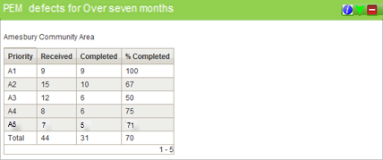

The table contains the following information

* Table **"PEM defects – Over seven months"** will be based on the following activities - AF, DP, FP, FT, GR, LC, NS, PA, PL, PT, SL, SW,WD CK, CL, CW, DC, DD, FW, HF, HO, KE, RA, SB, SF, SN, TH, VG, VK,WM
* Measure of Attendance (PEM) Defects, for **Over Seven Months**.
* **Priority**: Attendance Priorities (*priority*)

|  |
| --- |
| A1 |
| A2 |
| A3 |
| A4 |
| A5 |

* **Received** - Number of defects with the Status field in MAI3806 set to ‘INSTRUCTED’
* **Completed** – Number of defects with the Status field in MAI3806 set to ‘COMPLETED’
* **% Completed** - % of those received that have been completed.

##### *Pseudo code*

From the IMF_MAI_DEFECT_REPAIRS view, group by the Attendance PRIORITY codes (plus a total row).

* Join IMF_MAI_DEFECT_REPAIRS to IMF_MAI_INSPECTIONS
  + - * Then exclude any defects which have initiation_type=’CMT’
* Join IMF_MAI_DEFECT_REPAIRS to IMF_NET_NETWORK_MEMBERS
  + - * network_element_id -> child_element_id
      * Restrict to relevant parent element (e.g. ‘COMM15’), passed in from parent POD, to restrict to that Community Area’s defects
* Join IMF_MAI_DEFECT_REPAIRS to IMF_MAI_WORK_ORDERS
  + - * Work_order_number -> work_order_number
* **Received** – Count the number of defects with the defect_status field set to ‘INSTRUCTED’
* **Completed** – Count the number of defects with the defect_status field set to ‘COMPLETED’
* **% Completed** - calculate the percentage of the total number of Completed defects, from the total number of Recevied defects
* Defect counts are based on date instructed being greater than the date range value passed in from the parent POD, e.g. based on a report date of ’01-JUL-2014’ for over 7 months ago (not including the last 4 weeks and preceeding 6 months):
  + - *date_instructed* between ’01-JAN-1900’ and ’31-NOV-2013’

## Report Set 3

This set of data is the same as the first set, but with the addition of an extra two columns which will help Wiltshire measure their own performance.

* **Average end to end time (days) of completed tickets (Date Recorded - Date Instructed) –** This measures the end to end time from the ‘Date Recorded’ field to the ‘Date Instructed’ field in MAI3806. This will allow us to check how long it is taking us to process PEMs and defects and get them sent to the contractor.
* **Average end to end time (days) of completed tickets (Date Recorded - Date Completed) –** This measures the time from the ‘Date Recorded’ field to the ‘Date Completed’ field in MAI3806. It provides a measure of the entire process.
* **Average end to end time (days) of completed tickets (Works Order Date Instructed - Date Completed) –** This measures the performance of the contractor by measuring from the ‘Date Instructed’ field to the ‘Date Completed’ field in MAI3806.
* Summary statistics page needs to show stats per area board and stats for the county as a whole.
* There are 18 community area boards and they are set up under Road Type ***COMA***. They a referenced in the system as follows:

|  |  |
| --- | --- |
| Road Group | Road Group Description |
| COMM15 | Amesbury Community Area |
| COMM7 | Bradford On Avon Community Area |
| COMM5 | Calne Community Area |
| COMM3 | Chippenham Community Area |
| COMM4 | Corsham Community Area |
| COMM11 | Devizes Community Area |
| COMM1 | Malmesbury Community Area |
| COMM6 | Marlborough Community Area |
| COMM8 | Melksham Community Area |
| COMM12 | Pewsey Community Area |
| COMM18 | Salisbury Community Area |
| COMM19 | Southern Wilts Community Area |
| COMM16 | South West Wilt Community Area |
| COMM13 | Tidworth Community Area |
| COMM9 | Trowbridge Community Area |
| COMM2 | Royal WB & Crick Community Area |
| COMM14 | Warminster Community Area |
| COMM10 | Westbury Community Area |

* The whole county can be selected by using ‘Road Type’ TOP and ‘Road Group’ WILTSHIRE ROADS – ALL COUNTY ROADS IN WILTSHIRE
* Last 7 days (include weekends)
* Last 4 weeks
* Last 3 months
* Last 6 months
* Last year
* Everything to date
* The summary page will be designed to look like the below, with links for each “date ranged” report. When you click the link in the field for the required Date Range & Area Board, it will drill down to the relevant table report, for the specific Area Board & Date Range selected.

##### 

##### *Pseudo code*

Select a distinct list of Group Type ***COMA*** Descriptions from IMF_NET_NETWORK_MEMBERS, to get the 18 Area Boards, plus Group Type ***TOP*** and Group Description ***WILTSHIRE ROADS – ALL COUNTY ROADS IN WILTSHIRE***, for the whole county. This should give 19 rows in total.

The subsequent 6 columns for the date ranges will all drill down to the same respective POD (per table), but with a different calculated date range date.

Example: Report run on 1st July 2014.

Last 7 Days (sysdate-7) = javascript:doDrillDown('*IM_TABLE7A*',’ COMM15’, '24-JUN-2014’)

Last 4 Weeks (sysdate-28) = javascript:doDrillDown('*IM_TABLE7A*',’ COMM15’, '03-JUN-2014’)

Last 3 Months (add_months(sysdate,-3)) = javascript:doDrillDown('*IM_TABLE7A*',’ COMM15’, '01-APR-2014’)

Last 6 months (add_months(sysdate,-6)) = javascript:doDrillDown('*IM_TABLE7A*',’ COMM15’, '01-JAN-2014’)

Last year (add_months(sysdate,-12)) = javascript:doDrillDown('*IM_TABLE7A*',’ COMM15’, '01-JUL-2013’)

Everything to date javascript:doDrillDown('*IM_TABLE7A*',’ COMM15’, '01-JAN-1900’)

* Tables **"Average number of days to instruct by defect type", "Average number of days to instruct highway defects"** & **"Average number of days to instruct PEM defects"** are shown below with instructions on which fields to read/filter the data from

### Table "Average number of days to instruct by defect type", "Average number of days to instruct highway defects", "Average number of days to instruct PEM defects"

* Defects with the Initiation Type ‘CMT’ (*initiation_type*) to be excluded from tables.

#### Average number of days to instruct by defect type

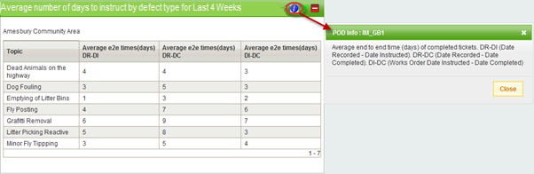

The table contains the following information

* **Activity codes** (*activity_code*) below identify each of the ‘Topic’ descriptions in Table “***Average number of days to instruct by defect type”***.

|  |  |
| --- | --- |
| DP | Dead Animals on the highway |
| AF | Dog Fouling |
| PL | Emptying of Litter Bins |
| FP | Fly Posting |
| GR | Grafitti Removal |
| SL | Litter Picking Reactive |
| FT | Minor Fly Tipping |

* **Average end to end time (days) of completed tickets (Date Recorded - Date Instructed) –** This measures the end to end time from the ‘Date Recorded’ field to the ‘Date Instructed’ field in MAI3806. This will allow us to check how long it is taking us to process PEMs and defects and get them sent to the contractor.
* **Average end to end time (days) of completed tickets (Date Recorded - Date Completed) –** This measures the time from the ‘Date Recorded’ field to the ‘Date Completed’ field in MAI3806. It provides a measure of the entire process.
* **Average end to end time (days) of completed tickets (Works Order Date Instructed - Date Completed) –** This measures the performance of the contractor by measuring from the ‘Date Instructed’ field to the ‘Date Completed’ field in MAI3806.

##### *Pseudo code*

From the IMF_MAI_DEFECT_REPAIRS view, group by the 7 ACTIVITY_CODE’s.

* Join IMF_MAI_DEFECT_REPAIRS to IMF_MAI_INSPECTIONS
  + Then exclude any defects which have *initiation_type*=’CMT’
* Join IMF_MAI_DEFECT_REPAIRS to IMF_NET_NETWORK_MEMBERS
  + *network_element_id -> child_element_id*
  + Restrict to relevant parent element (e.g. ‘COMM15’), passed in from parent POD, to restrict to that Community Area’s defects
* Join IMF_MAI_DEFECT_REPAIRS to IMF_MAI_WORK_ORDERS
  + Work_order_number -> work_order_number
* **Average end to end time (days) of completed tickets (Date Recorded - Date Instructed) –** calculate the average of *date_recorded-date_instructed* . Defect counts are based on the date completed being greater than the date range value passed in from the parent POD, e.g. based on a report date of ’01-JUL-2014’ for the last 4 weeks:
  + *defect_date_completed* >= ’03-JUN-2014’
* **Average end to end time (days) of completed tickets (Date Recorded - Date Completed) –** calculate the average of *date_recorded-defect_date_completed*. Defect counts are based on date instructed being greater than the date range value passed in from the parent POD, e.g. based on a report date of ’01-JUL-2014’ for the last 4 weeks:
  + *date_instructed* >= ’03-JUN-2014’
* **Average end to end time (days) of completed tickets (Works Order Date Instructed - Date Completed) –** calculate the average of *date_instructed-defect_date_completed*. Defect counts are based on the date completed being greater than the date range value passed in from the parent POD, e.g. based on a report date of ’01-JUL-2014’ for the last 4 weeks:
  + *defect_date_completed* >= ’03-JUN-2014’

#### Average number of days to instruct highway defects

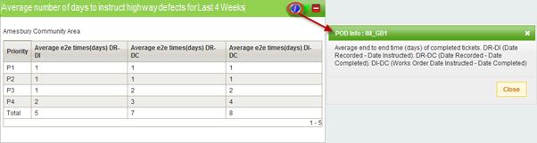

The table contains the following information

* Priority Codes (*priority*) in Exor

|  |  |
| --- | --- |
| P1 | 1,1P |
| P2 | 2 |
| P3 | 3 |
| P4 | 4 |

* **Average end to end time (days) of completed tickets (Date Recorded - Date Instructed) –** This measures the end to end time from the ‘Date Recorded’ field to the ‘Date Instructed’ field in MAI3806. This will allow us to check how long it is taking us to process PEMs and defects and get them sent to the contractor.
* **Average end to end time (days) of completed tickets (Date Recorded - Date Completed) –** This measures the time from the ‘Date Recorded’ field to the ‘Date Completed’ field in MAI3806. It provides a measure of the entire process.
* **Average end to end time (days) of completed tickets (Works Order Date Instructed - Date Completed) –** This measures the performance of the contractor by measuring from the ‘Date Instructed’ field to the ‘Date Completed’ field in MAI3806.

##### *Pseudo code*

From the IMF_MAI_DEFECT_REPAIRS view, group by the 4 PRIORITY CODE’s.

* Join IMF_MAI_DEFECT_REPAIRS to IMF_MAI_INSPECTIONS
  + Then exclude any defects which have *initiation_type*=’CMT’
* Join IMF_MAI_DEFECT_REPAIRS to IMF_NET_NETWORK_MEMBERS
  + *network_element_id -> child_element_id*
  + Restrict to relevant parent element (e.g. ‘COMM15’), passed in from parent POD, to restrict to that Community Area’s defects
* Join IMF_MAI_DEFECT_REPAIRS to IMF_MAI_WORK_ORDERS
  + Work_order_number -> work_order_number
* **Average end to end time (days) of completed tickets (Date Recorded - Date Instructed) –** calculate the average of *date_recorded-date_instructed* . Defect counts are based on the date completed being greater than the date range value passed in from the parent POD, e.g. based on a report date of ’01-JUL-2014’ for the last 4 weeks:
  + *defect_date_completed* >= ’03-JUN-2014’
* **Average end to end time (days) of completed tickets (Date Recorded - Date Completed) –** calculate the average of *date_recorded-defect_date_completed*. Defect counts are based on date instructed being greater than the date range value passed in from the parent POD, e.g. based on a report date of ’01-JUL-2014’ for the last 4 weeks:
  + *date_instructed* >= ’03-JUN-2014’
* **Average end to end time (days) of completed tickets (Works Order Date Instructed - Date Completed) –** calculate the average of *date_instructed-defect_date_completed*. Defect counts are based on the date completed being greater than the date range value passed in from the parent POD, e.g. based on a report date of ’01-JUL-2014’ for the last 4 weeks:
  + *defect_date_completed* >= ’03-JUN-2014’

#### Average number of days to instruct PEM defects

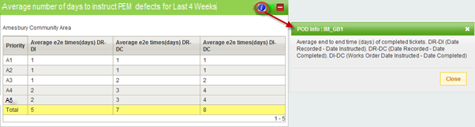

The table contains the following information

* **Priority**: Attendance Priorities (*priority*)

|  |
| --- |
| A1 |
| A2 |
| A3 |
| A4 |
| A5 |

* **Average end to end time (days) of completed tickets (Date Recorded - Date Instructed) –** This measures the end to end time from the ‘Date Recorded’ field to the ‘Date Instructed’ field in MAI3806. This will allow us to check how long it is taking us to process PEMs and defects and get them sent to the contractor.
* **Average end to end time (days) of completed tickets (Date Recorded - Date Completed) –** This measures the time from the ‘Date Recorded’ field to the ‘Date Completed’ field in MAI3806. It provides a measure of the entire process.
* **Average end to end time (days) of completed tickets (Works Order Date Instructed - Date Completed) –** This measures the performance of the contractor by measuring from the ‘Date Instructed’ field to the ‘Date Completed’ field in MAI3806.

##### *Pseudo code*

From the IMF_MAI_DEFECT_REPAIRS view, group by the 4 Attendance PRIORITY CODE’s.

* Join IMF_MAI_DEFECT_REPAIRS to IMF_MAI_INSPECTIONS
  + Then exclude any defects which have *initiation_type*=’CMT’
* Join IMF_MAI_DEFECT_REPAIRS to IMF_NET_NETWORK_MEMBERS
  + *network_element_id -> child_element_id*
  + Restrict to relevant parent element (e.g. ‘COMM15’), passed in from parent POD, to restrict to that Community Area’s defects
* Join IMF_MAI_DEFECT_REPAIRS to IMF_MAI_WORK_ORDERS
  + Work_order_number -> work_order_number
* **Average end to end time (days) of completed tickets (Date Recorded - Date Instructed) –** calculate the average of *date_recorded-date_instructed* . Defect counts are based on the date completed being greater than the date range value passed in from the parent POD, e.g. based on a report date of ’01-JUL-2014’ for the last 4 weeks:
  + *defect_date_completed* >= ’03-JUN-2014’
* **Average end to end time (days) of completed tickets (Date Recorded - Date Completed) –** calculate the average of *date_recorded-defect_date_completed*. Defect counts are based on date instructed being greater than the date range value passed in from the parent POD, e.g. based on a report date of ’01-JUL-2014’ for the last 4 weeks:
  + *date_instructed* >= ’03-JUN-2014’
* **Average end to end time (days) of completed tickets (Works Order Date Instructed - Date Completed) –** calculate the average of *date_instructed-defect_date_completed*. Defect counts are based on the date completed being greater than the date range value passed in from the parent POD, e.g. based on a report date of ’01-JUL-2014’ for the last 4 weeks:
  + *defect_date_completed* >= ’03-JUN-2014’

# Appendices

## Appendix A

### IMF_MAI_INSPECTIONS

|  |  |  |  |
| --- | --- | --- | --- |
| **Column** | **Type** | **Size** | **Column Comments** |
| ============================== | ========== | ====== | ==================================== |
| INSPECTION_ID | NUMBER | 22 | The internal id of the Inspection. |
| INSPECTION_BATCH_ID | NUMBER | 22 | The internal batch id that the Inspection is associated with. |
| SAFETY_DETAILED_FLAG | CHAR | 1 | The Inspections Safety/Detailed flag. |
| SAFETY_DETAILED_DESCRIPTION | CHAR | 11 | The Safety/Detailed flag description. |
| INITIATION_TYPE | CHAR | 10 | The Inspections Initiation Type. |
| INITIATION_TYPE_DESCRIPTION | CHAR | 52 | The Initiation Type description. |
| SURFACE_CONDITION | CHAR | 4 | The road surface conditions at the time of the inspection. |
| WEATHER_CONDITION | CHAR | 4 | The weather conditions at the time of the inspection. |
| PRIMARY_INSPECTOR_ID | NUMBER | 22 | Internal User id of the Primary Inspector. |
| PRIMARY_INSPECTOR_INITIALS | CHAR | 3 | The Primary Inspectors initials. |
| PRIMARY_INSPECTOR_NAME | CHAR | 30 | The Primary Inspectors name. |
| SECONDARY_INSPECTOR_ID | NUMBER | 22 | Internal User id of the Secondary Inspector. |
| SECONDARY_INSPECTOR_INITIALS | CHAR | 3 | The Secondary Inspectors initials. |
| SECONDARY_INSPECTOR_NAME | CHAR | 30 | The Secondary Inspectors name. |
| NETWORK_ELEMENT_ID | NUMBER | 22 | The internal id of the Network Element that the Inspection is associated with. |
| START_OFFSET | NUMBER | 22 | The Offset at which the Inspection began. |
| END_OFFSET | NUMBER | 22 | The Offset at which the Inspection ended. |
| DATE_OF_ENTRY | DATE |  | The date the Inspection details were entered into the system. |
| DATE_INSPECTED | DATE |  | The date the Inspection was performed. |
| DATE_LOADED | DATE |  | The date the Inspection details were loaded into the system. |
| NUMBER_OF_DEFECTS | NUMBER | 22 | The number of Defects recorded during the Inspection. |

### IMF_MAI_DEFECT_REPAIRS

|  |  |  |  |
| --- | --- | --- | --- |
| **Column** | **Type** | **Size** | **Column Comments** |
| ============================== | ========== | ====== | ================================================== |
| DEFECT_ID | NUMBER | 22 | The internal id of the Defect. |
| DEFECT_STATUS | CHAR | 10 | The Defect Status Code. |
| DEFECT_STATUS_DESCRIPTION | CHAR | 30 | The Defect Status description. |
| DEFECT_DESCRIPTION | CHAR | 240 | Defect description. |
| LOCATION_DESCRIPTION | CHAR | 1000 | The Location Description held against the Defect. |
| SPECIAL_INSTRUCTIONS | CHAR | 254 | Any Special Instructions held against the Defect. |
| PRIORITY | CHAR | 4 | The Defect Priority |
| PRIORITY_DESCRIPTION | CHAR | 52 | The Defect Priority description |
| PRIORITY_INTERVAL | CHAR | 4 | The Interval associated with the Defect Priority |
| DEFECT_TYPE | CHAR | 4 | The Defect Type |
| DEFECT_TYPE_DESCRIPTION | CHAR | 40 | The Defect Type description. |
| DIAGRAM_NUMBER | CHAR | 240 | The Defect Diagram Number |
| HEIGHT | NUMBER | 22 | The Height of the Defect |
| LENGTH | NUMBER | 22 | The Length of the Defect |
| AREA | NUMBER | 22 | The Area of the Defect |
| ASSET_MODIFICATION_CODE | CHAR | 1 | The Asset Modification Code associated with the Defect. |
| ASSET_MODIFICATION_DESCRIPTION | CHAR | 52 | The Asset Modification description |
| NOTIFY_ORGANISATION_ID | NUMBER | 22 | The internal id of the Organisation to be Notified of the Defect |
| NOTIFY_ORGANISATION_CODE | CHAR | 10 | The Code of the Organisation to be Notified of the Defect. |
| NOTIFY_ORGANISATION_NAME | CHAR | 40 | The Name of the Organisation to be Notified of the Defect. |
| RECHARGE_ORGANISATION_ID | NUMBER | 22 | The internal id of the Organisation to be Charged for the repair of the Defect |
| RECHARGE_ORGANISATION_CODE | CHAR | 10 | The Code of the Organisation to be Charged for the repair of the Defect |
| RECHARGE_ORGANISATION_NAME | CHAR | 40 | The Name of the Organisation to be Charged for the repair of the Defect |
| SUPERSEDED | CHAR | 1 | Flag indicating whether the Repair has been superseded. (Y/N) |
| SUPERSEDED_BY_DEFECT_ID | NUMBER | 22 | The internal id of the Defect that has superseded this Defect. |
| DATE_INSPECTED | DATE |  | The date that the Inspection was carried out. |
| DATE_RECORDED | DATE |  | The date the Defect was entered\loaded into the system. |
| DEFECT_DATE_COMPLETED | DATE |  | The date the Defect was completed. |
| DATE_NOT_FOUND | DATE |  | The date the Defect was not refound during a subsequent Inspection of the same type |
| NOT_FOUND_INSPECTION_ID | NUMBER | 22 | The internal id of the subsequent Inspection during which the Defect was not refound |
| NETWORK_ELEMENT_ID | NUMBER | 22 | The internal id of the Network Element that the Defect is associated with |
| NETWORK_ELEMENT_OFFSET | NUMBER | 22 | The Offset, relative to the Network Element, at which the Defect was observed |
| XSP | CHAR | 1 | The XSP code, relative to the Network Element, at which the Defect was observed |
| XSP_DESCRIPTION | CHAR | 52 | The XSP description. |
| EASTING | NUMBER | 22 | The easting (x co-ordinate) at which the Defect was observed. |
| NORTHING | NUMBER | 22 | The northing (y co-ordinate) at which the Defect was observed. |
| ASSET_TYPE | CHAR | 4 | The Type of Asset that the Defect is associated with. |
| ASSET_ID | NUMBER | 22 | The internal id of the Asset that the Defect is associated with. |
| INSPECTION_ID | NUMBER | 22 | The internal id of the Inspection. |
| INSPECTION_BATCH_ID | NUMBER | 22 | The internal batch id that the Inspection is associated with. |
| PRIMARY_INSPECTOR_ID | NUMBER | 22 | Internal User id of the Primary Inspector. |
| PRIMARY_INSPECTOR_INITIALS | CHAR | 3 | The Primary Inspectors initials. |
| PRIMARY_INSPECTOR_NAME | CHAR | 30 | The Primary Inspectors name. |
| ACTIVITY_CODE | CHAR | 2 | The Activity Code associated with the Repair. |
| ACTIVITY_DESCRIPTION | CHAR | 60 | The Activity description. |
| REPAIR_CATEGORY | CHAR | 1 | Repair category |
| REPAIR_CATEGORY_DESCRIPTION | CHAR | 52 | repair category description |
| TREATMENT_CODE | CHAR | 4 | Treatment code |
| TREATMENT_DESCRIPTION | CHAR | 40 | Treatment description |
| REPAIR_DESCRIPTION | CHAR | 240 | Repair description |
| DATE_CREATED | DATE |  | The date the Repair was created within the system. |
| DATE_DUE | DATE |  | The date the Repair is due to by completed by. |
| REPAIR_DATE_COMPLETED | DATE |  | The date the Repair was completed. |
| REPAIR_TIME_COMPLETED_HOURS | NUMBER | 22 | The hour upon which the repair was completed. |
| REPAIR_TIME_COMPLETED_MINS | NUMBER | 22 | The minute upon which the repair was completed. |
| REPAIR_LATE | CHAR | 1 | Indicates whether the repair was late. (Y/N) |
| DAYS_TO_DATE_DUE | NUMBER | 22 | The number of days until the Repair Date Due. |
| HOURS_TO_DATE_DUE | NUMBER | 22 | The number of hours until the Repair Date Due. |
| DAYS_COMPLETED_BEFORE_DUE | NUMBER | 22 | The number of days prior to the Due Date that the repair was completed (A negative value indicates the number of days late) |
| HOURS_COMPLETED_BEFORE_DUE | NUMBER | 22 | The number of hours prior to the Due Date that the repair was completed (A negative value indicates the number of hours late) |
| DAYS_SINCE_INSPECTED | NUMBER | 22 | Days since an inspection took place |
| HOURS_SINCE_INSPECTED | NUMBER | 22 | Hours since an inspection took place |
| WORKS_ORDER_NUMBER | CHAR | 16 | The Works Order Number associated with the Repair. |
| BOQ_PERCENT_UPLIFT_CODE | CHAR | 10 | The BOQ percent uplift Standard Item Code associated with the Repair |
| BOQ_PERCENT_UPLIFT_DESCRIPTION | CHAR | 254 | The BOQ percent uplift description |
| WOL_PERCENT_UPLIFT_CODE | CHAR | 10 | The Work Order Line percent uplift Standard Item Code associated with the Repair |
| WOL_PERCENT_UPLIFT_DESCRIPTION | CHAR | 254 | The Work Order Line percent uplift description |

### IMF_MAI_WORK_ORDERS

|  |  |  |  |
| --- | --- | --- | --- |
| **Column** | **Type** | **Size** | **Column Comments** |
| ============================== | ========== | ====== | ================================================== |
| WORKS_ORDER_NUMBER | CHAR | 16 | The Works Order Number. |
| WORKS_ORDER_DESCRIPTION | CHAR | 100 | The Works Order Description. |
| WORKS_ORDER_STATUS | CHAR | 10 | The current status of the Works Order. |
| WORKS_ORDER_TYPE | CHAR | 1 | The Works Order Type, e.g. M - Cyclic Maintenance or D - Defect Clearance |
| WORKS_ORDER_TYPE_DESCRIPTION | CHAR | 52 | The Works Order Type Description |
| INTERIM_PAYMENT | CHAR | 1 | Interim Payments can be made? (Y/N) |
| PRIORITY | CHAR | 1 | The Works Order Priority code. |
| PRIORITY_DESCRIPTION | CHAR | 52 | The Works Order Priority meaning. |
| NETWORK_ELEMENT_ID | NUMBER | 22 | Internal id of the Road Group associated with the Works Order. |
| SYS_FLAG | CHAR | 1 | The Sys Flag of the Road Group associated with the Works Order (L/D). |
| SYS_FLAG_DESCRIPTION | CHAR | 52 | Sys Flag description. |
| SCHEME_TYPE | CHAR | 2 | The Works Order Scheme Type. |
| SCHEME_TYPE_DESCRIPTION | CHAR | 52 | The Works Order Scheme Type description. |
| REGISTER | CHAR | 1 | The Works should be included in the TMA Register? (Y/N) |
| REGISTER_STATUS | CHAR | 1 | The Status of the Works within the TMA Register. |
| REGISTER_STATUS_DESCRIPTION | CHAR | 52 | The description of the Status of the Works within the TMA Register. |
| CONTRACT_ID | NUMBER | 22 | The internal id of the Contract associated with the Works Order. |
| CONTRACT_CODE | CHAR | 10 | The Code of the Contract that the Works Order is assigned to. |
| CONTRACT_NAME | CHAR | 40 | The Name of the Contract that the Works Order is assigned to. |
| CONTRACTOR_ID | NUMBER | 22 | The internal id of the Contractor associated with the Contract. |
| CONTRACTOR_CODE | CHAR | 10 | The Code of the Contractor associated with the Contract. |
| CONTRACTOR_NAME | CHAR | 40 | The Name of the Contractor associated with the Contract. |
| CONTACT | CHAR | 80 | The Contact details on the Works Order |
| ORIGINATOR_ID | NUMBER | 22 | The internal id of the person that raised the Works Order. |
| ORIGINATOR_INITIALS | CHAR | 3 | The initials of the person that raised the Works Order. |
| ORIGINATOR_NAME | CHAR | 30 | The name of the person that raised the Works Order. |
| AUTHORISED_BY_ID | NUMBER | 22 | The internal id of the person who authorised the Works Order. |
| AUTHORISED_BY_INITIALS | CHAR | 3 | The initials of the person who authorised the Works Order. |
| AUTHORISED_BY_NAME | CHAR | 30 | The name of the person who authorised the Works Order. |
| COST_CENTRE | CHAR | 3 | The Cost Centre code associated with the Works Order. |
| JOB_NUMBER | CHAR | 5 | The Job Number associated with the Works Order. |
| RECHARGABLE | CHAR | 1 | Is the Cost of the Works rechargable to an external organisation? (Y/N). |
| COST_RECHARGED | NUMBER | 22 | The Total Cost that has been recharged to an external organisation. |
| REMARKS | CHAR | 1000 | General remarks held against the Works Order. |
| DATE_RAISED | DATE |  | The date the Works Order was raised. |
| DAYS_SINCE_RAISED | NUMBER | 22 | The number of days since the Works Order was raised. |
| TARGET_DATE | DATE |  | The Target Completion Date of the Works Order. |
| DAYS_TO_TARGET_DATE | NUMBER | 22 | The number of days until the Target Completion date of the Works Order. |
| DATE_INSTRUCTED | DATE |  | The date the Works Order was Instructed. |
| DAYS_SINCE_INSTRUCTED | NUMBER | 22 | The number of days since the Works Order was Instructed. |
| DATE_LAST_PRINTED | DATE |  | The date the Works Order was printed. |
| DATE_RECEIVED | DATE |  | The date the Works Order was marked as Received. |
| DAYS_SINCE_RECEIVED | NUMBER | 22 | The number of days since the Works Order was marked as Received. |
| RECEIVED_BY_ID | NUMBER | 22 | The internal id of the person who marked the Works Order as Received. |
| RECEIVED_BY_INITIALS | CHAR | 3 | The initials of the person who marked the Works Order as Received. |
| RECEIVED_BY_NAME | CHAR | 30 | The name of the person who marked the Works Order as Received. |
| DATE_COMPLETED | DATE |  | The date the Works Order was completed. |
| DAYS_SINCE_COMPLETED | NUMBER | 22 | The number of days since the Works Order was completed. |
| ESTIMATED_COST | NUMBER | 22 | The Estimated Cost of the Works Order. |
| ESTIMATED_BALANCING_SUM | NUMBER | 22 | The Estimate Balancing Sum of the Works Order. |
| ESTIMATED_TOTAL | NUMBER | 22 | The Estimated Cost + the Estimated Balancing Sum. |
| LABOUR_UNITS | NUMBER | 22 | The Total number of Labour Units associated with the Works Order. |
| ACTUAL_COST | NUMBER | 22 | The Actual Cost of the Works Order. |
| ACTUAL_BALANCING_SUM | NUMBER | 22 | The Balancing Sum to be applied to the Actual Cost of the Works Order. |
| ACTUAL_TOTAL | NUMBER | 22 | The sum of the Actual Cost and the Actual Balancing Sum. |

### IMF_NET_NETWORK_MEMBERS

|  |  |  |  |
| --- | --- | --- | --- |
| **Column** | **Type** | **Size** | **Column Comments** |
| ============================== | ========== | ====== | ============================ |
| PARENT_ELEMENT_ID | NUMBER | 22 | Parent Element Id |
| PARENT_ELEMENT_REFERENCE | CHAR | 30 | Parent Element Reference |
| PARENT_ELEMENT_DESCRIPTION | CHAR | 240 | Parent Element Description |
| PARENT_NETWORK_TYPE | CHAR | 4 | Parent Network Type |
| PARENT_GROUP_TYPE | CHAR | 4 | Parent Group Type |
| PARENT_ELEMENT_START_DATE | DATE |  | Parent Element Start Date |
| PARENT_ELEMENT_END_DATE | DATE |  | Parent Element End Date |
| CHILD_ELEMENT_ID | NUMBER | 22 | Child Element Id |
| CHILD_ELEMENT_REFERENCE | CHAR | 30 | Child Element Reference |
| CHILD_ELEMENT_DESCRIPTION | CHAR | 240 | Child Element Description |
| CHILD_NETWORK_TYPE | CHAR | 4 | Child Network Type |
| CHILD_GROUP_TYPE | CHAR | 4 | Child Group Type |
| CHILD_ELEMENT_START_DATE | DATE |  | Child Element Start Date |
| CHILD_ELEMENT_END_DATE | DATE |  | Child Element End Date |
| MEMBERSHIP_START_DATE | DATE |  | Membership Start Date |
| MEMBERSHIP_END_DATE | DATE |  | Membership End Date |

## Appendix B

### MAI3806 – Defects

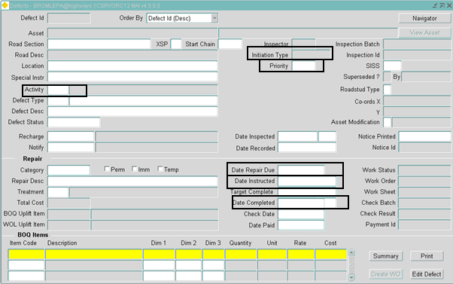

## Appendix C

### IMF Views ERD

